**Nama:** Clive Clay Irawan

**NIM:** 2702373412

**Binary Search Tree**

Create a Binary Search Tree with the input given below:

98, 2, 48, 12, 56, 32, 4, 67, 23, 87, 23, 55, 46

Then:

1. Insert 21, 39, 45, 54, 63 into the tree.
2. Delete 23, 56, 2, 45 from the tree.

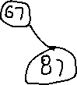

Delete 23

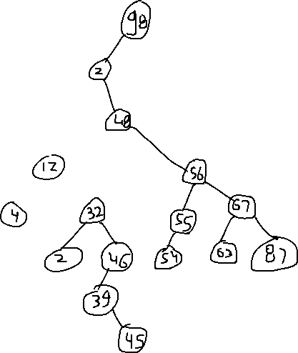

Delete 56

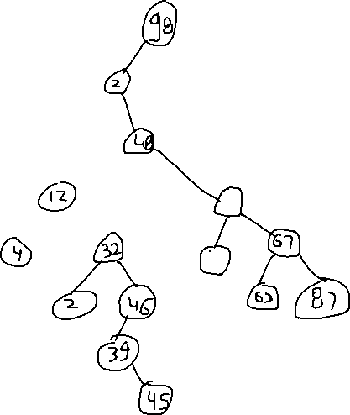

Delete 2

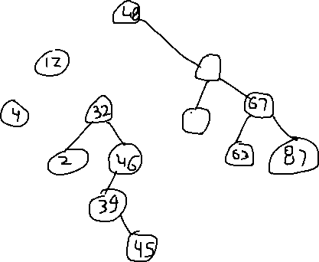

Delete 45

